CITY OF BELMONT
Facilities for Hire

Redcliffe Community Centre & Reserve

Redcliffe Community Centre features a large main hall with a stage area, ideal for weddings, plays/productions, dance classes and large social functions. The multi-purpose room is primarily used by sporting clubs but due to the room having an enclosed play area attached it is ideal for smaller functions such as children’s birthday parties. The center also has two small meeting rooms. Redcliffe Community Centre is adjacent to a sporting reserve that is primarily used for softball and social cricket.
GENERAL INFORMATION
Address | 33 Morgan Road, Redcliffe (main carpark comes off Grand Parade)
Access Friendly | Yes, access friendly parking, toilets and ramps available
CCTV | Yes (cameras will not be turned off for bookings and are not permitted to be obstructed at any time)
Parking | Yes – large carpark off Grand Parade (39 bays) and smaller carpark off Morgan Rd (8 bays)
Wi-Fi | No
Equipment | Items such as TV’s, projectors, audio/visual equipment and also cleaning equipment etc. are not provided and not available for hire through the City. Hirers have to supply all their own required equipment.
ROOMS AVAILABLE FOR HIRE

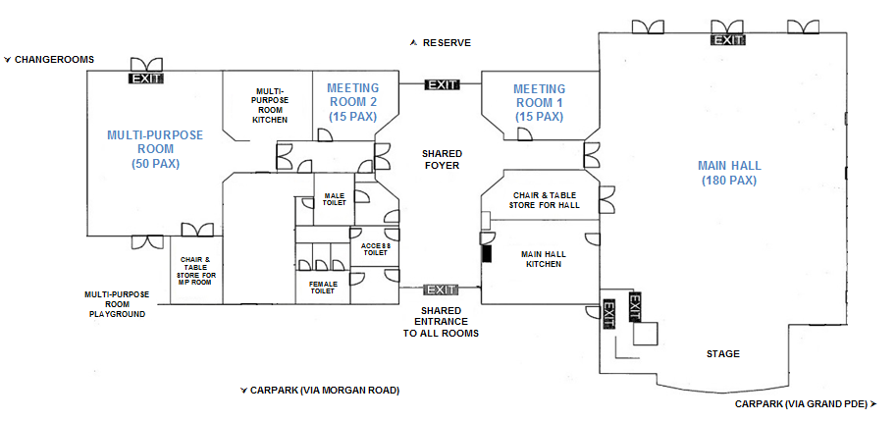

CURRENTLY
UNAVAILABLE

MAIN HALL
​Size |  | ​Approximately 13m x 18m (234sqm)
​Max Capacity |  | ​180 people (It is an offence under the Health Act 1911 to exceed the maximum capacity stipulated on the certificate of approval)
​Floor |  | ​Timber
​Chairs |  | ​180 (measurements and photos available upon request)
​Tables |  | ​25 trestle tables - 1800mm x 750mm (photos available upon request)
​Air Conditioning |  | ​Evaporative (cooling only)
​Kitchen |  | Yes, included in hire is a large kitchen with a fridge/freezer, large gas stove and electric oven, auto boiler urn, microwave and a servery into the hall. Hirers are required to bring all their own plates/cutlery/cookware/cleaning equipment. The kitchen is to be used for warming up food purposes only.
Toilets |  | Yes - shared facilities with the Multipurpose Room & Meeting Rooms (located in foyer)
Additional |  | - This hall features a stage area with a manual fold out stage curtain  - There is a small pin board available for use during the time of hire  - There is an external door that leads into the backstage area

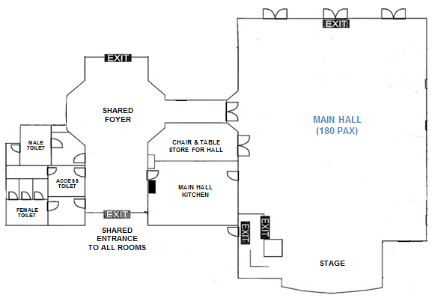
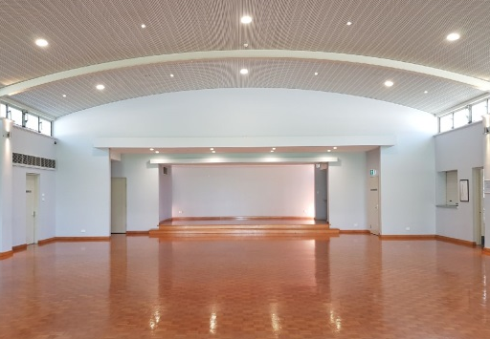
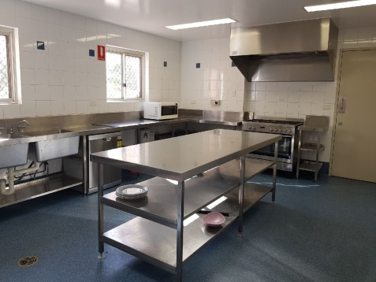

Hall Kitchen
Hall (view of stage area)
Hall (looking towards reserve)
Areas Included in Hire (toilets and foyer shared use)

​MEETING ROOM 1 – CURRENTLY UNAVAILABLE
Size | Approximately 20sqm
​Max Capacity | ​15 people (It is an offence under the Health Act 1911 to exceed the maximum capacity stipulated on the certificate of approval)
​Floor | ​Carpet
​Chairs | ​15 (measurements and photos available upon request)
​Tables | 3 trestle tables - 1800mm x 750mm (photos available upon request)
​Air Conditioning | ​Evaporative (cooling only)
​Kitchen | ​None included
Toilets | Yes - shared facilities with the Hall & Multipurpose Room (located in foyer)
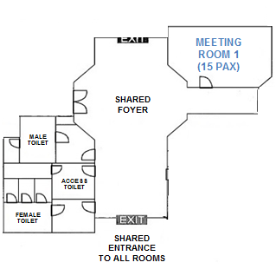

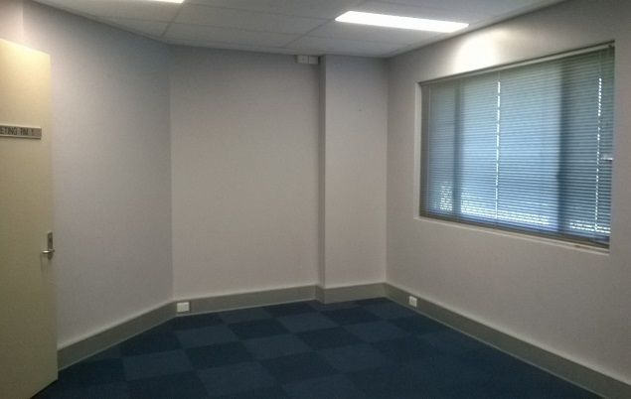
Areas Included in Hire (toilets and foyer shared use)

CURRENTLY
UNAVAILABLE

Meeting Room 1

Meeting Room 1

​MULTI-PURPOSE ROOM
Size | Approximately 9.5m x 7m (66sqm)
​Max Capacity | ​50 people (It is an offence under the Health Act 1911 to exceed the maximum capacity stipulated on the certificate of approval)
​Floor | ​Vinyl
​Chairs | ​50 (measurements and photos available upon request)
​Tables | 7 trestle tables - 1800mm x 750mm (photos available upon request)
​Air Conditioning | ​Split System (heating & cooling)
​Kitchen | ​Yes, included in hire is a kitchen with a fridge/freezer, small gas stove and oven, auto boiler urn, microwave and a servery into the room. Hirers are required to bring all their own plates/cutlery/cookware/cleaning equipment. The kitchen is to be used for warming up food purposes only.
Toilets | Yes - shared facilities with the Hall & Meeting Rooms (located in foyer)
Additional | - Small enclosed play area (slide, sandpit etc.) under a shade sail  - Pin boards available for use during the time of hire
Note | The kiosk roller door that serves outside is not available to casual hirers.
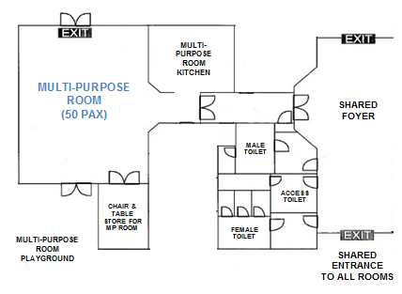
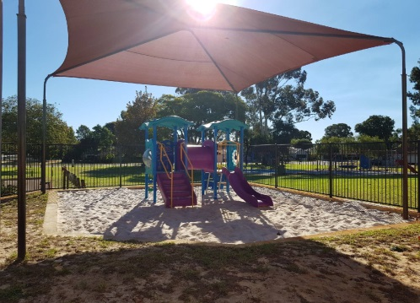
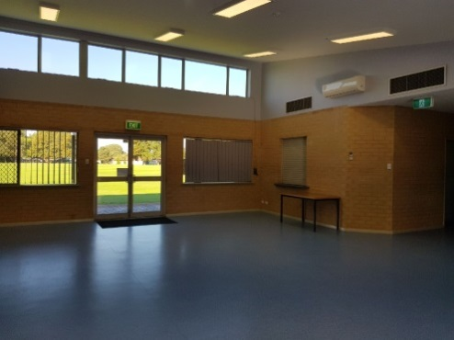

Multi-Purpose Room

Kitchen (showing roller door servery)
Enclosed Play Area

Areas Included in Hire (toilets and foyer shared use)
Enclosed Play Area
Multi-Purpose Room

​MEETING ROOM 2
Size | Approximately 15sqm
​Max Capacity | ​15 people (It is an offence under the Health Act 1911 to exceed the maximum capacity stipulated on the certificate of approval)
​Floor | ​Carpet
​Chairs | ​15 (measurements and photos available upon request)
​Tables | 3 trestle tables - 1800mm x 750mm (photos available upon request)
​Air Conditioning | ​No – ceiling fan only
​Kitchen | ​ None included
Toilets | Yes - shared facilities with the Hall & Multipurpose Room (located in foyer)
Additional | Due to a window overlooking the foyer area this room is not very private
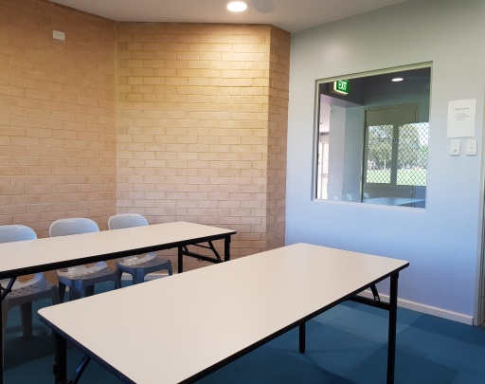
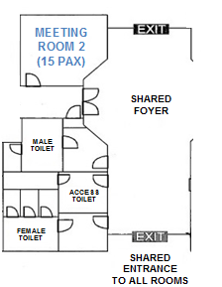
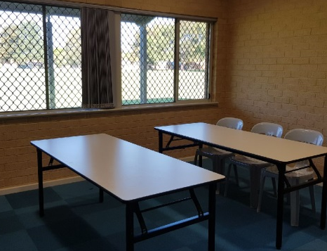

Areas Included in Hire
(toilets and foyer shared use)

Meeting Room 2
Meeting Room 2
RESERVE/PARK AREA
Sport Hire  (fees applicable) | SUMMER: Tee-Ball & Softball – Line markings in place 1 Oct - 30 March  ANNUAL: There is a cricket pitch here all year round (not available for night time hire)
Parking | Parking is available in the centre carparks and in the bays provided on Grand Parade
Toilets | No public toilets are located outside.
Oval Lighting | There are two light towers available – fees are applicable and suitable for large ball sport training only.
Changerooms | Yes – available for hire with reserve (toilets/showers)
Playgrounds | There is a free to use playground located near the Philomel Close end
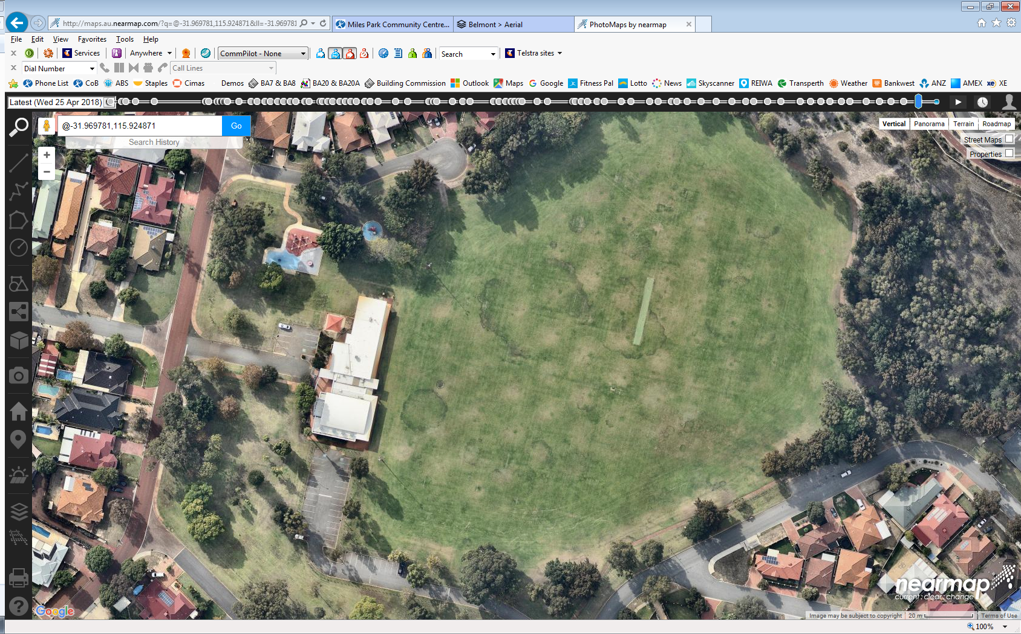

PHILOMEL CL

PLAYGROUND
(

FIELD AVE
CHANGE ROOMS
CHANGEROOMS
(during summer)
CRICKET PITCH
(all year round)
(during summer)

MULTI-PURPOSE ROOM
(during summer)
MORGAN RD
MEETING ROOMS
(during summer)
SMALL CARPARK
(via Morgan Rd)
(during summer)

MAIN HALL
(during summer)
ADDITIONAL PARKING

LARGE CARPARK
(Grand Parade)
(during summer)

GRAND PDE

Video tours of this facility are available on the City’s website
http://www.belmont.wa.gov.au/Community/VenuesForHire

For further information and availability please contact venue.hire@belmont.wa.gov.au

